

MATHEMATICS
APPLICATIONS

Test 2 – Sequences

Chapter 1 and 2
Semester 1 2018

Section One - Calculator Free

Time allowed for this section
Working time for this section: 25 minutes
Marks available: 27 marks

Material required/recommended for this section

To be provided by the supervisor
This Question/Answer booklet
Formula sheet

To be provided by the candidate
Standard items: pens, pencils, pencil sharpener, eraser, correction fluid, ruler, highlighters

Special items: Nil

Important note to candidates
No other items may be used in this section of the examination. It is your responsibility to ensure that you do not have any unauthorised notes or other items of a non-personal nature in the examination room. If you have any unauthorised material with you, hand it to the supervisor before reading any further.

- (2 marks)
Calculate the sum of all the multiples of 5 between 1 and 50.

- (5 marks)
A sequence of numbers is described by the recursive equation , where .
  - Determine [1]

  - Determine [1]

  - State a rule for the n^{th} term of this sequence. [2]

  - Determine [1]

- (5 marks)
  - A sequence is defined by , where .
    - State a rule for the n^{th} term of this sequence in simplified form. [1]

    - Determine [1]

  - The first-order recurrence relation was used with to calculate and . Determine the values of b, c and . [3]

- (8 marks)
The number of laptop computers, $T_{n}$, that were brought to a school IT department for recharging during week $n$ of the school year can be described recursively by the rule
$$T_{n+1}=T_{n}+3, T_{4}=16$$

- Use the rule to complete the table below. [2]

$$n$$ | 1 | 2 | 3 | 4 | 5 | 6 | 7
$$T_{n}$$

- Display the terms of the sequence from the table on the graph below. [2]
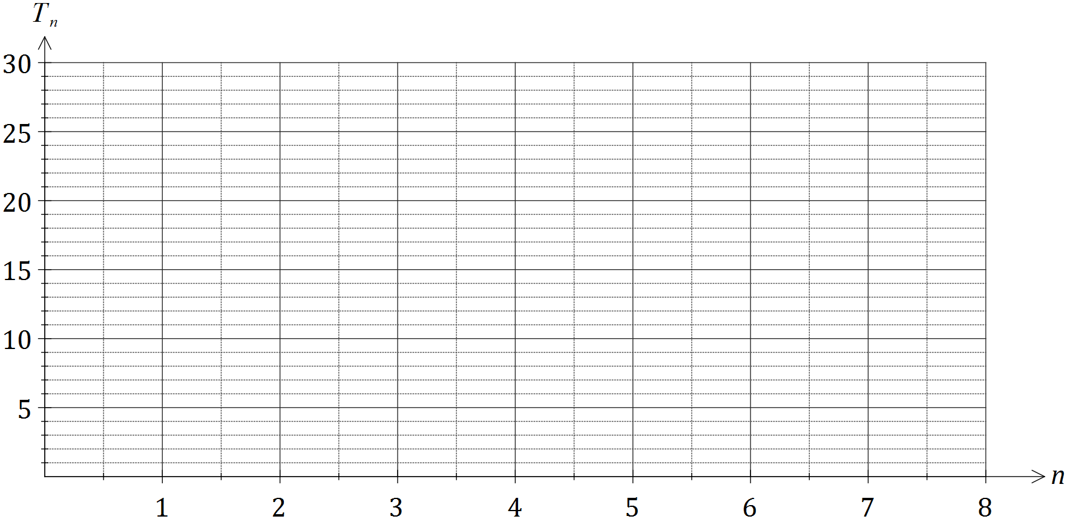

- A rule to determine the number of laptops brought for recharging during week $n$ can also be written in the form $T_{n}=an+b$. Determine the values of $a$ and $b$. [2]

- If the pattern continued, determine the number of the week during which the number of laptops brought in for recharging first exceeds 50. [2]

- (7 marks)
The sixth term of an arithmetic sequence is double its fourth term. The first term of the sequence is 20 and the common difference is d.
  - Show that [3]

  - Hence, find the recursive rule for the sequence. [4]

Extra space for working if required

End of Section One

